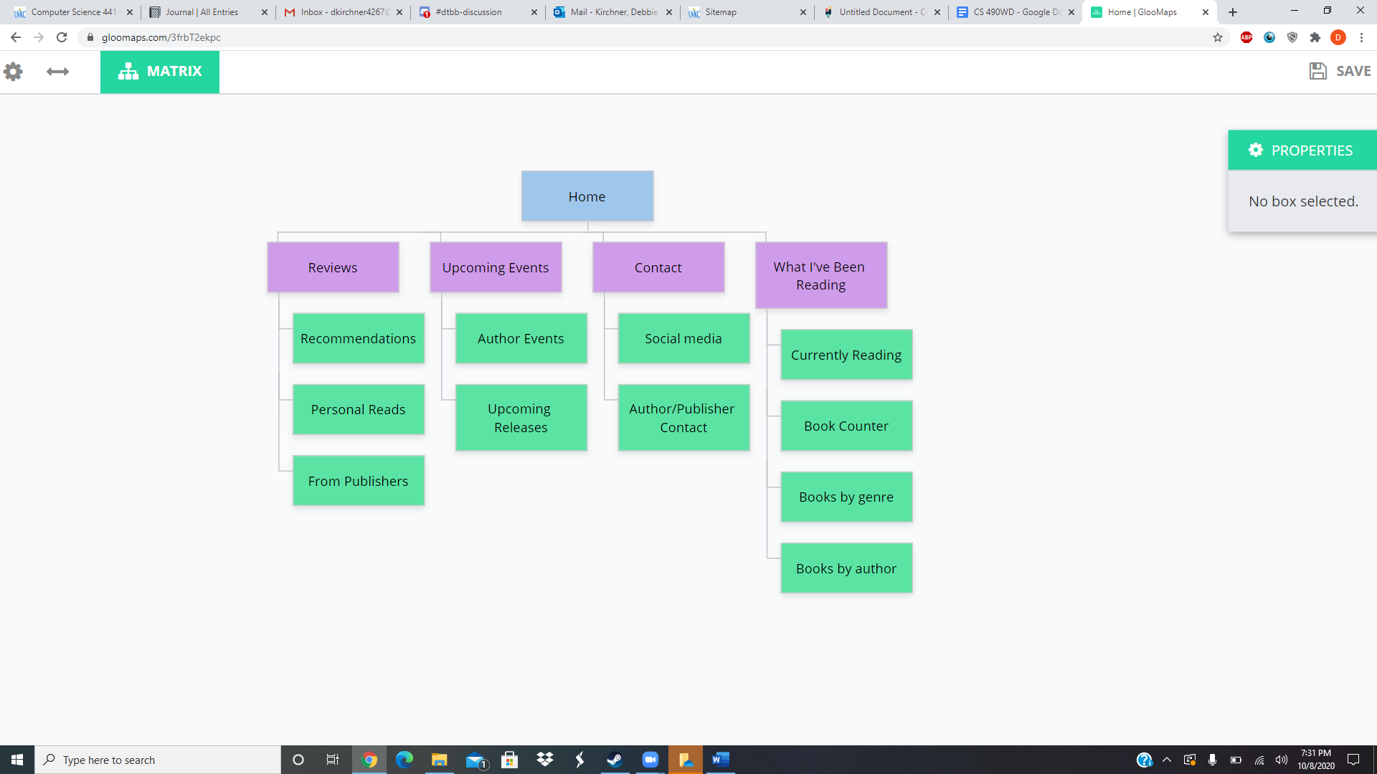

<https://www.gloomaps.com/3frbT2ekpc>